MTCS – 103(P) Parallel Processing

Labwork 4 Report
by
Sai Suraj - 21560

I have developed a sequential code for Matrix Multiplication of size N where
rows of A are multiplied to columns of B. I have used a Global variables for Size
N, Matrix A, B, and Resulting Matrix C. I am getting a randomized value and dividing them by a random number assigned and obtaing the remainder as input value for Matrix A and B.I also write the input value in a text file for using it next time.input files are in format matA_N and matB_N where N is the order of matrix.

I have checked for correctness of my program. And Executed the code for
matrices of int of size N= 500, 1000,1500, 2000,2500,3000,4000 and tabulate
the execution time taken in each case. I have taken average for 3 number of
runs. Plotted the change in the total execution time to compare.

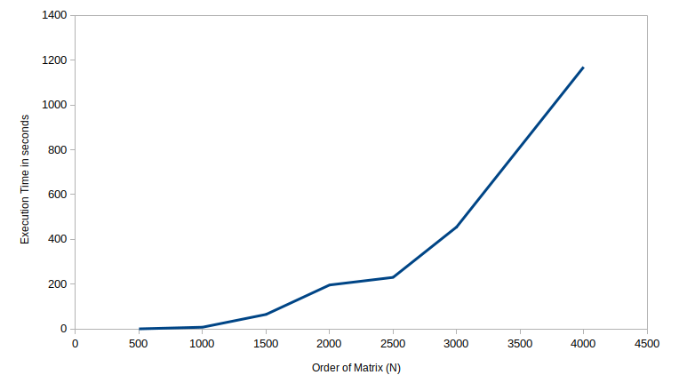

For Smaller Matrix size, The Execution time remains constant at 0. And, As
Matrix size increases, execution time increases.

Since I am using Intel(R) Core(TM) i7-8550U CPU @ 1.80GHz with 2 VCPU’s , It takes more time to compute.If i have used 2 more cores computation might have been better and faster.

